SEMESTER ONE EXAMINATION 2011
Stage 3a Applied Information Technology
Marks (200)
1 |  | 20
2 |  | 30
3 |  | 50
4 |  | 100
TOTAL

Student Curriculum Council Number:

TIME ALLOWED FOR THIS PAPER
Reading Time: Ten Minutes
Working Time for Paper Three Hours

MATERIALS REQUIRED/RECOMMENDED FOR THIS PAPER
TO BE PROVIDED BY THE SUPERVISOR
This Question Booklet to include your answers
TO BE PROVIDED BY THE CANDIDATE
Standard Items: pens, pencils, crayons, eraser or correction fluid/tape, ruler
Special Items: calculator satisfying the conditions set by the Curriculum Council

IMPORTANT NOTE TO CANDIDATES
No other items may be taken into examination room.
It is your responsibility to ensure that you do not have any unauthorised notes or other items of a non-personal nature in the examinations room. If you have any unauthorised material with you, hand it to the supervisor BEFORE reading any further.

INSTRUCTIONS TO STUDENTS
Write all answers in pen
Allowed pens, eraser, correction fluid/tape, and ruler.
This paper is in four (4) sections.
SECTION 1: Multiple Choice. Attempt ALL questions (20 questions = 20 marks)
Indicate your answer on this answer sheet and complete the multiple choice box.
SECTION 2: Short Answers. SIX (6) questions.....EACH MUST BE ATTEMPTED. NO CHOICE. (6 questions = 30 marks)
Write your answer on this answer sheet.
SECTION 3: Extended Answers. Extended Answer TWO (2) questions.
(2 questions = 50 marks).
Write your answer on this answer sheet.
SECTION 4: Production questions.
(all questions = 100 marks).
Write your answer on this answer sheet.

Answer all questions on this paper (you may highlight or circle the appropriate answer) then put your answers on this Multiple-choice Answer Box provided as a, b, c or d. You will be marked on the answers given here.

If you make a mistake, place a cross through that answer and write in your new answer

Multiple Choice Answer Box
(answer a, b, c or d)
1 |  | 11
2 |  | 12
3 |  | 13
4 |  | 14
5 |  | 15
6 |  | 16
7 |  | 17
8 |  | 18
9 |  | 19
10 |  | 20
Total

YOU MUST WRITE ON THIS PAPER

Section One: Multiple-Choice |  | 10% (20 Marks)

Answer all questions on this paper (you may highlight or circle the appropriate answer) then put your answers on the Multiple-choice Answer Box provided as: a, b, c or d. You will be marked on the answers given there.

Suggested working time: 20 minutes.

- The phrase ‘green computing’ most commonly refers to

- Energy – efficient enabled computers.
- Sharing of resources between computer systems.
- Making local CPU resources available for networked projects.
- Reusing software scrap for future projects.

- What is an author required to do in order to assert copyright on their intellectual property?

- Include their name on the work.
- Register their work with the government.
- Retain possession of the original copy of the work.
- Nothing: copyright is assigned automatically.

- The main difference between a tablet computer and a netbook is that the tablet computer has

- A colour screen.
- A touch screen.
- No internal hard drive.
- No built-in networking facilities.

- The process of ‘defragmentation’ of a hard drive involves the

- Removing unwanted files to increase the amount of free space.
- Backing up files to reorganize them logically.
- Moving files to make existing files and free space contiguous.
- Creating new directories to make existing files easier to access.

- A new version of software is said to be ‘backwards compatible’ if

- It can read data files created using previous versions.
- It can read data files in either previous or future versions.
- Data files created can be read using previous versions.
- Data files created can be read in either previous or future versions.

- Software that is provided for use, modification, and redistribution is called

- Shareware
- Freeware
- Custom software
- Open Source Software

- A ‘firewall’ is security software that inspects and controls network traffic

- Into a computer.
- Out of a computer.
- In both directions.
- In neither directions.

- Which design principle is illustrated by the following pictures?

- Balance.
- Emphasis.
- Proportion.
- Harmony.

- Downloading movies and music without permission violates laws related to

- Equity.
- Intellectual property.
- Copyright.
- Fair use or fair dealing.

- ‘requirements analysis’ involves determining what

- Physical resources will be needed for a project.
- Human resources will be needed for a project.
- Features the client expects from a system.
- Facilities the system needs in order to perform its tasks.

- The principal feature of a web page that uses push technology in that the

- Client doesn’t initiate the transfer of information.
- Server doesn’t contain all of the necessary information.
- Information is transferred via a number of different channels
- Information is encrypted at the server rather than at the client

- ‘Technological convergence’ is best understood as different

- Industries evolving to use similar approaches.
- Technologies evolving to perform similar tasks.
- Tasks evolving to use similar technologies
- Professions evolving to employ similar methods.

- Which of the following network topologies uses a ‘control token’?

- Tree network
- Ring network
- Mesh network
- Star network

- The principal difference between the HTTP and HTTPS protocols is that

- HTTP can transfer larger files.
- HTTPS can transfer files faster.
- HTTP can transfer more file types.
- HTTPS can transfer files more securely.

- Which one of the following applications would be used in ‘desktop publishing’?

- Adobe Acrobat Reader.
- Three panel brochure.
- A text book on desktop publishing.
- Web page.

- How many frames per second are generally required to achieve real-time computer animation?

- 6
- 60
- 600
- 6, 000

- A NIC (Network Interface Card) enables a computer to

- Establish virtual links between your computer and any peripheral.
- Establish a link to networked peripherals.
- Establish a link directly to the internet.
- All of the above.

- A student wants to choose a storage format for a photo story she has produced which has a file size of 900 000 kilo bytes. Which would be the most suitable storage medium?

- Floppy Disk (1.44 MB)
- CD-RW (800 MB)
- DVD-R (4.7 GB)
- USB (Flash or Thumb) Drive (256 MB)

- The best way without cabling, to network computers throughout your home is through:

- a DSL modem.
- an ISDN modem.
- a network card.
- a wireless router.

- When using a lossless compression, the compression and un-compression of a file results in a file that is

- Smaller in size than the original file.
- The same size as the original file.
- 10 K larger in size to the original file.
- Larger in size than the original file.

End of Section One

Section Two: Short answer
15% (30 Marks)
This section has six (6) questions. Answer all questions.
Write your answers in the space provided.
Spare pages are included at the end of this booklet. They can be used for planning your responses and/or as additional space if required to continue an answer.
- Planning: If you use the spare pages for planning, indicate this clearly at the top of the page.
- Continuing an answer: IF you need to use the space to continue an answer, indicate in the original answer space where the answer is continue, i.e. give the page number. Fill in the number of question(s) that you are continuing to answer at the top of the page.
Suggested working time: 20 Minutes

Question 21 (4 marks)
Outline four ways in which the effective use of ICT can increase the productivity of manufacturing industries.

Question 22 (5 marks)
- Define ‘inclusivity’ as it applies to the design of an ICT product or service. (1 mark)

- A design needs to be made inclusive of an ageing population. Identify four barriers to inclusivity and outline their solutions. (4 marks)
One:

Two:

Three:

Four:

Question 23 (6 marks)
- Describe four aspects of an ICT project that need to be monitored and documented over the course of its development.
(4 marks)

- Define ‘top-down’ as a project management strategy.
(1 mark)

- Define ‘bottom-up’ as a project management strategy.
(1 mark)

Question 24 (2 marks)
Describe briefly the type of network traffic the following protocols control.
- HTTP (1 mark)

- SMTP (1 mark)

Question 25 (11 marks)
You wish to outsource the purchasing of a number of computers.
- List four criteria you would use to select a company to supply the computers.
(4 marks)

- To minimize the cost you consider reusing old computer components and peripherals in or with your new computers. Describe, with a suitable example, two problems that may be encountered.
(4 marks)

- A company does not have an IT support department. Describe three ways in which it could support its staff that use computers.
(3 marks)

Question 26 (2 marks)
A large international company has imposed a ban on accessing social networking sites from its computer networks. The employees would like to have this ban lifted.
List and justify two benefits that the company could gain from allowing its staff to access social networking sites.

End of Section Two

Section Three: Extended answer 25% (50 Marks)
This section has two (2) questions. You must answer both questions.
Write your answers in the space provided.
Spare pages are included at the end of this booklet. They can be used for planning your responses and/or as additional space if required to continue an answer.
- Planning: If you use the spare pages for planning, indicate this clearly at the top of the page.
- Continuing an answer: IF you need to use the space to continue an answer, indicate in the original answer space where the answer is continue, i.e. give the page number. Fill in the number of question(s) that you are continuing to answer at the top of the page.
Suggested working time: 50 Minutes

Question 27 (25 marks)
Firefly Fine Dining is an international restaurant chain. It has restaurants situated in almost every continent and in smaller nations located in the Caribbean Sea and The Pacific and Indian Oceans. Each restaurant has been positioned in popular tourist areas. The management of Firefly wants all transactions conducted at the restaurants sent to its central database at the close of each restaurants business day. In addition, the management wants each restaurant to send all of its data files (which record sales, customer information, employee timesheets, payments made and supplies ordered) to its head office in Perth to be stored on the company’s server.
- All files from each location must be sent across the internet. Describe what the company could do to reduce the cost and time taken to transmit each file. (4 marks)
Cost:

Time:

- The company’s head office wants to conduct a video conference meeting with all of its managers at the same time. Discuss four issues that would affect the success of the conference and suggest alternative methods that would address these issues.
(8 marks)

- Some of the information that is sent from various locations around the world to the head office is confidential. Explain four methods that would ensure the security and integrity of data on a PC before it was sent.
(8 marks)

- The data collected at the head office is stored in a data warehouse. Explain what a data warehouse is and list three ways in which the management could use the data to benefit the company.
(5 marks)

Question 28 (25 marks)
Nimble Office has recently conducted an internal review of its employees and discovered that some employees have a basic knowledge of the use of ICT. You have been asked to advise Nimble Office on how to improve these employees’ knowledge of and skills in processing and managing typical office data, such as text documents and spreadsheets.
To advise Nimble Office on this issue, you must address the following:
- Outline three criteria that can be used to determine competent use of standard office applications. (6 marks)
- Develop a methodology for assessing the extent to which employees meet these three criteria. (6 marks)
- Describe four strategies for improving the knowledge of and skills in processing and managing typical office data. (8 marks)
- If the company were to implement a new ‘employee information system’, recommend and justify two features that should be included to help it manage all employees’ knowledge and skills while accommodating the rapid changes in ICT.
(5 marks)

Section Four: Production 50% (100 Marks)
There is one question in this section. You must answer all parts of the question.
Spare pages are included at the end of this booklet. They can be used for planning your responses and/or as additional space if required to continue an answer.
- Planning: If you use the spare pages for planning, indicate this clearly at the top of the page.
- Continuing an answer: IF you need to use the space to continue an answer, indicate in the original answer space where the answer is continue, i.e. give the page number. Fill in the number of question(s) that you are continuing to answer at the top of the page.
Suggested working time: 75 Minutes

Question 29
A company called AnyTime-AnyWhere Network Solutions is an Internet Service Provider (ISP).
AnyTime-AnyWhere has a website that allows potential and existing customers to browse its products and services. The website also has a variety of features for its customers. Existing customers can log in and access the status of their internet accounts as well as access chat rooms where they can discuss various issues and topics.
AnyTime-AnyWhere wishes to increase its access to a new market audience that includes users of mobile technologies such as web enabled mobile phones, PDAs and other mobile internet capable devices. To do this AnyTime-AnyWhere wants to create a website that can be viewed on and suit the design features of mobile devices. The website will be called the mobile website.
Your task is to develop a mobile website for AnyTime-AnyWhere to be viewed on mobile devices.

An example of a mobile device is provided below. It has a display that is 3.5 inches (8.9cm) diagonally and 480 x 320 pixel resolution at 163 ppi.
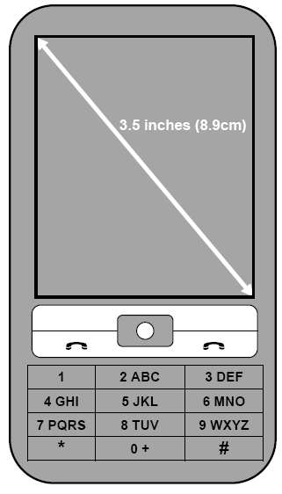

In order to develop a mobile website, you will need to complete four parts of the task. An overview of this process is outlined below:
Part 1: Pre-design: Identify trends in mobile computing. Analyze the design of a website and mobile website. (30 marks)
Part 2: Design: Explore how to meet AnyTime-AnyWhere’s design criteria. Design a mobile website. (28 marks)
Part 3: Analysis: Justify how your design meets the requirements (30 marks)
Part 4: Modification of design: Modify your design of a mobile website so that it is inclusive of older users. (12 marks)
Part 1: Pre-design (30 marks)
- In preparation for designing AnyTime-Anywhere’s mobile website, identify five emerging ICT trends, outlining briefly how they will inform your design.
(5 marks)
One:

Two:

Three:

Four:

Five:

- Discuss two issues relating to social implications and trends raised in the article ‘Paypal brings m-commerce to Australia’ below. (4 marks)
PayPal brings m-commerce to Australia
PayPal has added mobile commerce (m-commerce) to its range of services offered to Australian mobile phone users, which the launch of PayPal Mobile Checkout.
The service offers consumers the opportunity to make instant and secure payments to businesses through a mobile phone.
When using the service, customers can access sites designed for mobile devices on their mobile phone and purchase products and services using their PayPal account.
Not all mobile phones will be able to access mobile websites and purchase products and services, only users with “smart phones” that have secure payment functionality built into their operating systems will be able to participate.

To assist you in developing the mobile website AnyTime-AnyWhere has provided an example of a website (Stimulus A) and a mobile website (Stimulus B) from a competitor’s site.
- Identify (by circling and naming) five design features for the website (5 Marks)
Stimulus A: website
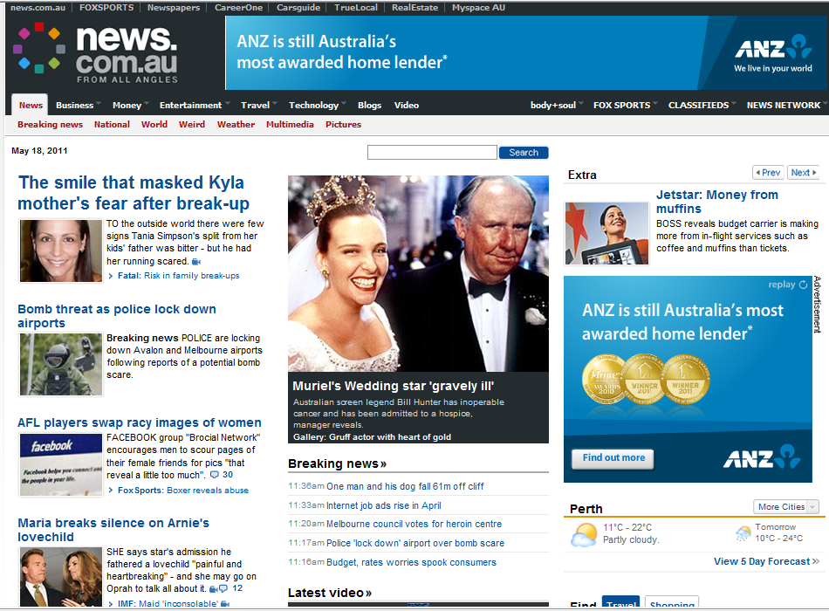
(The bottom part of this webpage is not shown here)

1
2
3
4
5
Stimulus B: mobile website
- Identify (by circling and naming) five design features for the mobile website.
(5 Marks)

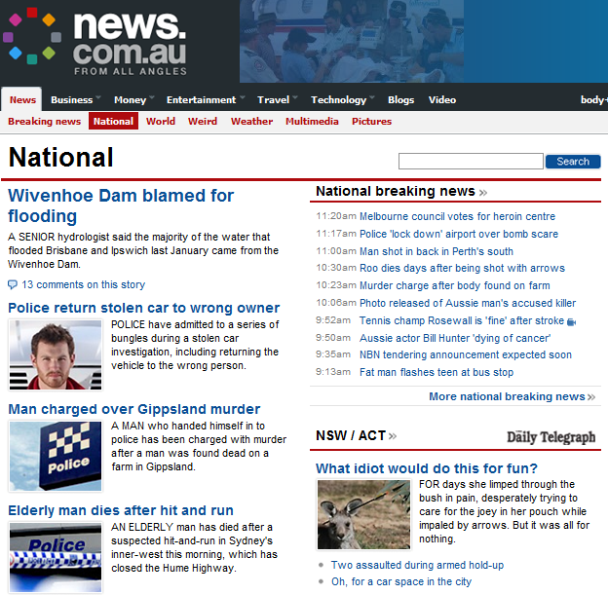

(The bottom part of this webpage is not shown here)

1
2
3
4
5

- Compare the stimulus materials A and B and explain why certain design features are used to suit the specific viewing requirements of a website and a mobile website. Refer to four of the design features identified in part (c) to support your response.
(11 marks)

Part 2: Pre-design (28 marks)
- AnyTime-AnyWhere has given you five design criteria that it wants incorporated into its mobile website. Justify briefly one way in which you could meet each of the criteria listed below in your design for a mobile website.
AnyTime-AnyWhere design criteria:
 | 1 | Meet user needs quickly | (2 marks)
 | 2 | Distinguish clearly selected items | (2 marks)
 | 3 | Make user input as simple as possible | (2 marks)
 | 4 | Display only essential information | (2 marks)
 | 5 | Design manageable page layouts for users of a mobile device | (2 marks)

Below is a snapshot taken from AnyTime-AnyWhere’s website. Design a sample mobile website using some or all of the content presented in the snapshot.
In your design you must: (18 Marks)

- incorporate AnyTime-AnyWhere’s design criteria | (5 marks)
- address one emerging ICT trend (identified in Part 1) | (2 marks)
- address one social trend (identified in Part 1) | (2 marks)
- select design features for a mobile device (identified in Part 1(c)) | (5 marks)
- use an appropriate design methodology to manage your ideas (e.g. clear sketches, dimensions, annotations, sequencing of work, checklists, etc.) | (4 marks)

Mobile website design

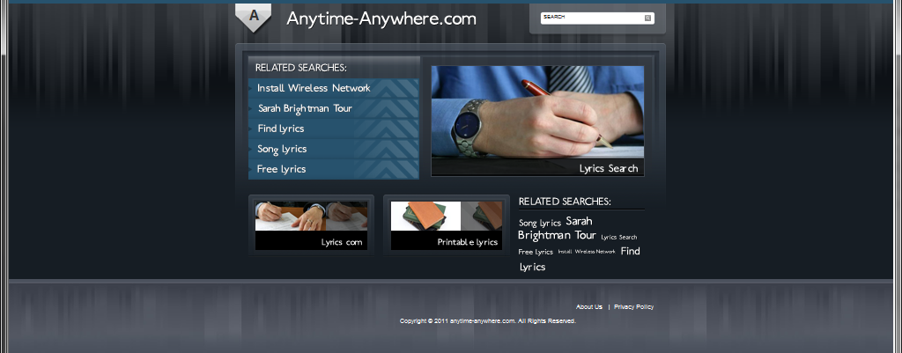

Sponsored Links Page
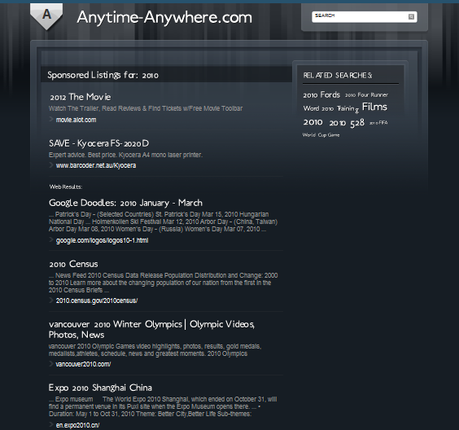

Working space for mobile website design, more design sheets are available at the end of this document if required.

Part 3: Analysis (30 marks)

(a) Justify how your mobile website design addresses the design criteria and how your
selection of three design features suits the viewing requirements for a mobile website for each of the design criteria.

(25 marks)

AnyTime-AnyWhere’s design criteria

1. Meet user needs quickly (5 Marks)
2. Distinguish clearly selected items (5 Marks)
3. Make user input as simple as possible (5 Marks)
4. Display only essential information (5 Marks)
5. Design manageable page layouts for users of a mobile device. (5 Marks)

- Outline the ICT trend and the social trend you selected to incorporate in the design of your mobile website. Explain why you selected these trends and how they are relevant to your design.
(5 marks)

Part 4: Modification of design (12 marks)

AnyTime-AnyWhere wants you to modify your design to be inclusive of older mobile device
users. The company has given you the following design requirements:

1. Make obvious what is clickable and what is not. (3 Marks)
2. Implement an ‘Important and frequently visited topics’ section. (3 Marks)
3. Include a site map link that can be accessed from every page. (3 Marks)
4. Use language that is simple and easily understood. (3 Marks)

Modify your mobile website design, using appropriate annotations to outline how you have incorporated the above design requirements.

Modified mobile website design:

Additional working space for mobile website design, if required.
Note: Further working space is provided at the end of this document.

Additional answer page
Continuation of question: ________________________________

Additional answer page
Continuation of question: ________________________________

Additional answer page
Continuation of question: ________________________________

Additional answer page
Continuation of question: ________________________________

Part 1(b)
Adapted from: Inside Retailing Online. (2007). PayPal brings m-commerce to
Australia. Retrieved April, 2010, from
http://www.insideretailing.com.au/Latest/tabid/53/ID/8431/PayPal-continues-Ozgrowth.
aspx.
Part 1(c)
News.com.au. (2010). [Screenshot from web page]. Retrieved January 12, 2010,
from http://www.news.com.au/.
News.com.au. (2010). [Screenshot of web page from mobile device]. Retrieved
January 12, 2010, from http://m.news.com.au/.
Part 2(b)
Images from: Anytime-Anywhere.com. (2010). [Screenshot from website].
Retrieved January, 2010, from http://anytime-anywhere.com/.

END OF EXAM

